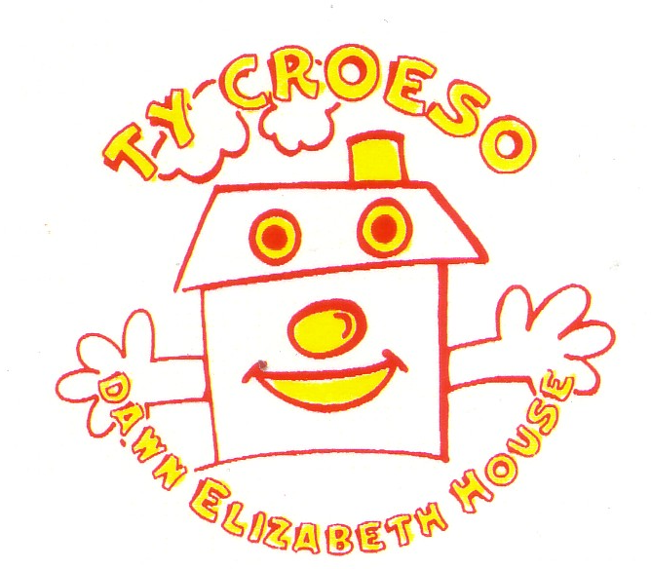
TY CROESO
DAWN ELIZABETH HOUSE
Parent’s Accommodation Lletty Rhieni Ysbyty Glan Clwyd Hospital Bodelwyddan, Rhyl

LL18 5UJ 01745 534782
Reg charity 519191
SPONSOR FORM

EVENT……………………….……………………………DATE…………………..

NAME…………………………………………………………………………………
I am a UK taxpayer and understand that if I pay less Income Tax and/or Capital Gains Tax in the current tax year than the amount of Gift Aid claimed on all my donations it is my responsibility to pay any difference.
*TO ALLOW US TO CLAIM GIFT AID (AN EXTRA 25P IN EVERY POUND) YOU NEED TO BE A UK TAX PAYER AND PROVIDE YOUR POSTCODE
NAME ADDRESS POSTCODE * AMOUNT GIFT AID

CONTINUED NAME………………………………………………………………………………………………………..

SPONSOR FORM TY CROESO DAWN ELIZABETH HOUSE YSBYTY GLAN CLWYD REG CHARITY NO. 519191

